We have been inside because of the Coronavirus
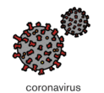

The government have said we can go outside now but we still have to be safe
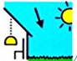
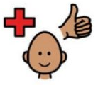

The government have said we have to wear a face mask when we go to the shops or supermarkets because this will help us to keep safe
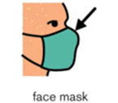

My family and I will have to wear a face mask when we go to the shops or the supermarkets
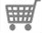
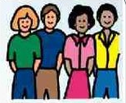

I will not be able to see people’s noses, mouths and chins because they will be covered.
This will look a little strange at first but it is okay because they will help to keep us safe

If I feel worried or upset about people wearing masks I will speak to my parents and they will help me to feel calmer
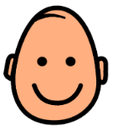
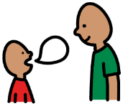
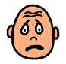

I will try to wear my face mask when I am at the shops or supermarkets
